Advice for Applicants
In March 2020, the Great Artesian Basin Senior Officials Committee agreed to establish a scholarship grant program in honour of the work and achievements of Mr Lynn Brake, Senior Research Fellow with the University of South Australia and his contributions to water management in the Great Artesian Basin.
Lynn Brake played a pivotal role on the Great Artesian Basin Coordinating Committee (GABCC) in its important function of providing strategic advice on a range of matters, including the development of the Great Artesian Basin Strategic Management Plan. The outcome of his efforts and those of the GABCC members has assisted in the fostering of a long-term cooperative approach with water users and other stakeholders, supporting Basin communities and industries. In particular, his enormous energy and dedication has enhanced the protection of the Great Artesian Basin mound springs.
The Scholarship Grant Program honours Lynn Brake’s legacy in the area of water resources in Australia and aims to support the development of future scientists and researchers and to help foster the links between academia, the wider community, and governments.
The Great Artesian Basin Lynn Brake Scholarship will support one or more applicants at any one time with a total annual grant of $20,000 (plus GST). The annual $20,000 may be awarded in full to one applicant or split equally across multiple applicants.
Funding for the Lynn Brake Scholarship is available for twelve months from the execution of the Grant Agreement with the Grant Recipient. To access support for more than one year an applicant must re-apply the following year through a competitive public call.

To be eligible applicants must:
- be an Australian citizen or permanent resident of Australia, over 18 years of age, AND
- have an unconditional acceptance to study at an Australian University, Tertiary Institution or Research Centre AND
- have an undergraduate or post graduate degree
Their research must:
- contribute to water-related knowledge of the Great Artesian Basin and its future management, AND
- be linked to the Great Artesian Basin Strategic Management Plan, AND
- have the primary focus within the Great Artesian Basin
Our expectations of you:
- A short summary report (one page)
- A final report (four pages)
- A presentation to the Great Artesian Basin Advisory Committee (GABSAC) and the Great Artesian Basin Senior Officials Committee (GABSOC)
To apply please provide:
- A two-page proposal on your research and how your research contributes to the GAB Strategic Management (see template and further pages below for guidance)
- Proof of Australian residency and enrolment
- A letter of support from your supervisor/s
- A letter of support from a local, or state government agency, landholder or community group relevant to your research

Name:
Contact Details: | P:  M:  E:
Institution:
Supervisor/s: | Name:  P:  M:  E:
Attached at least two letters of support | - A letter of support from your supervisor/s  - A letter of support from a local, or state government agency, landholder or community group relevant to your research
Proposal
Period of proposal:
Topic:

Background: the context for research

Research approach and methods: the proposal for research

Engagement and collaboration: specify connections with community groups or government agencies

Relationship to the Great Artesian Basin Strategic Management Plan: suggest how the research may have applications for the management of the GAB

Budget: anticipated expenditure

Further detail on project eligibility and assessment criteria

  - Eligible grant activities and location
To be eligible your research activity must:
- contribute to the intended outcomes of the Great Artesian Basin Lynn Brake Scholarship, and
- be related to the research project as outlined in your application.

Research can include activities outside of, but relevant to, the Great Artesian Basin, although the primary focus must lie within the Basin.
  - Eligible grant expenditure
Successful applicants can only spend the grant on eligible activities related to the research in your application which they have incurred between the start date and completion date of the grant agreement. Eligible expenditure items can include but are not limited to:
- site visits
- industry visits such as travel and accommodation (excluding per diems)
- purchase of research materials
- specific research activities
- publishing in journals
- presentations at conferences or workshops relative to the grant agreement
- purchase of data, data analytics packages or subscriptions
- purchase of research subscriptions
- purchase of audio/visual recording equipment directly related to the research project

  - Ineligible grant activities
Applicants cannot use the grant for the following activities:
- research related to activities that are already funded on an ongoing basis by other Australian, state or territory, or local government programs
- research activities that commenced prior to the grant agreement being finalised, such as capital costs
- administration costs associated with the payment of the grant to the grantee
- purchase of land
- wages
- major capital expenditure
- the covering of retrospective costs
- costs incurred in the preparation of a grant application or related documentation
- subsidy of general ongoing administration of an organisation such as electricity, phone and rent
- major construction/capital works
- overseas travel, and
- activities for which other Commonwealth, state, territory or local government bodies have primary responsibility.
  - Grant assessment
The applications must address how the project aligns with the seven guiding principles for managing the Great Artesian Basin to achieve economic, environmental, cultural and social outcomes outlined in the Great Artesian Basin Strategic Management Plan.

An assessment committee panel will assess each application on its merit and compare it to other eligible applications before recommending which grant applications should be awarded a grant. The following criteria will be used for this assessment.

Table 1: Scholarship assessment criteria and assessment weighting of each criteria
Criterion | Weighting | Examples of what to include
1: Innovative or emerging scientific issue in a field directly related to the Great Artesian Basin | 20% | - demonstrated need for the research  - scientific focus or creative angle  - originality of data.
2: Potential of the project to provide long-term benefits to Great Artesian Basin industries and or communities | 20% | - potential financial benefits of the research  - sustainability of the Great Artesian Basin as a result of the research  - stakeholder uptake through information dissemination and communication.
3: Relevant to the Strategic Management Plan’s seven guiding principles for managing the Great Artesian Basin to achieve economic, environmental, cultural and social outcomes | 20% | - one or more of the Strategic Management Plan’s principles captured by the project  - how the objectives and desired outcomes for each principle will be achieved.
4: Potential for building linkages and collaboration between academia, industry, government and community sectors | 20% | - the collaborative nature of your research activities during the grant period  - the collaborative outcomes that will be enabled by your research in the longer-term.
5: Completion of activities within the agreed timeframe | 10% | - timeline of activities within the 12-month timeframe.
6: Value for money | 10% | - budget  - appropriateness of activities.

  - Who will approve the grant and appeal process
The Program Delegate (Assistant Secretary, National Water Policy, Water Division, Australian Department of Climate Change, Energy, the Environment and Water) decides which grant/s to approve, considering the recommendations of the assessment panel and the availability of grant funds for the purposes of the grant program.
The Program Delegate’s decision is final in all matters, including:
- the approval of the grant
- the grant funding amount to be awarded
- the terms and conditions of the grant.

There is no appeal mechanism for decisions to approve or not approve a grant.
  - Notification of the grant
We will advise the applicants of the outcome of their applications in writing. If you are successful, we will advise you of any specific conditions attached to the grant. Unsuccessful applicants may ask for feedback within 14 days of being advised of the outcome. We will give written feedback within one month of your request.

Applicants can submit a new application for the same grant in any future grant opportunities under the program. Applicants should include new or more information to address any weaknesses that may have prevented the previous application from being successful.

  - The grant agreement/Payment of the grant
The successful applicant must enter into a legally binding grant agreement with the Commonwealth. We use the standard grant agreement in this program. Each agreement has general terms and conditions that cannot be changed. Sample grant agreements are available on GrantConnect.

We must execute a grant agreement with you before we can make any payments. We are not responsible for any of your expenditure until a grant agreement is executed. If you choose to start your scholarship grant activities before you have an executed grant agreement, you do so at your own risk. The grant agreement may have specific conditions determined by the assessment process or other considerations made by the Program Delegate. We will identify these in the agreement.

The Commonwealth may recover grant funds if there is a breach of the grant agreement.

The successful applicant will have 30 days from the date of a written offer to execute this grant agreement with the Commonwealth (‘execute’ means both you and the Commonwealth have signed the agreement). During this time, we will work with you to finalise details. The offer may lapse if both parties do not sign the grant agreement within this time. Under certain circumstances, we may extend this period. We base the approval of your grant on the information you provide in your application.

The successful applicant may request changes to the grant agreement. However, we will review any required changes to these details to ensure they do not impact the grant as approved by the Program Delegate. The grant agreement will state the:
- maximum grant amount to be paid to the applicant
- eligible expenditure
- requirements the grantee must satisfy
We will not exceed the maximum grant amount under any circumstances. If you incur extra costs, you must meet them yourself.

We will make a one full payment on execution of the grant agreement to the Grant Recipient. The Grant Recipient will make payments in full to the applicant.

Great Artesian Basin Strategic Management Plan
The latest version of the Great Artesian Basin Strategic Management Plan (the Plan) was released in July 2020. The Australian, Northern Territory, Queensland, South Australian and New South Wales governments worked together to prepare it.
We developed the Plan in consultation with the Great Artesian Basin Coordinating Committee (GABCC), stakeholders, and considered feedback through a public consultation process.
The Plan provides a framework for governments, Aboriginal and Torres Strait Islanders, water users and other stakeholders to achieve economic, environmental, cultural and social outcomes for the Great Artesian Basin and its users.
Implementation of the Plan will assist all parties to identify and respond to the risks, issues, challenges and opportunities associated with use of Basin water.
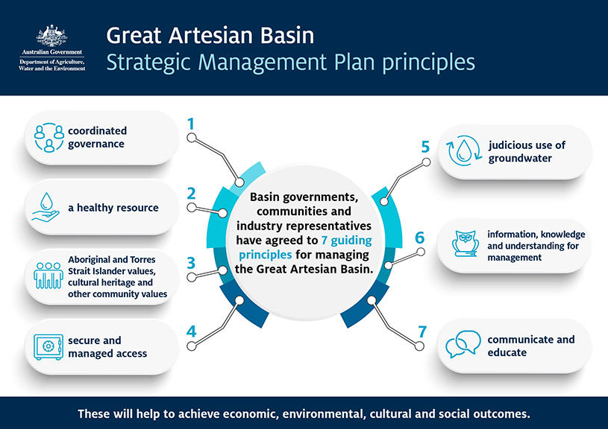
Basin governments, community and industry representatives agreed to 7 guiding principles. These are used to achieve economic, environmental, cultural and social outcomes for the Basin.
The Plan spans 15 years (ending 2034). It will be reviewed every 5 years.

Note 2 page maximum length
https://www.awe.gov.au/water/policy/national/great-artesian-basin/strategic-management-plan

